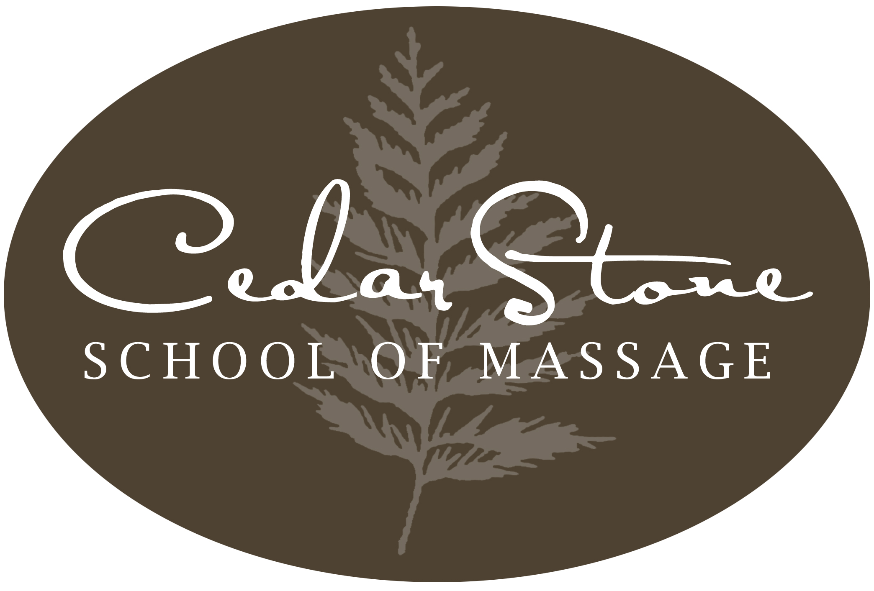

Summer 2018
Catalog

1834 South Main Street
Harrisonburg, VA 22801
540-801-0078


Table of Contents

School Calendar 3
Programs/Course Offerings 4
History and Development
Certification
General Description of Space, Equipment and Facilities

Massage Therapy Certification Programs 5
Massage for Friends and Family 7
Continuing Education 7
Course Descriptions 8
    - Level I Massage Therapy Class
- Level II Massage Therapy Class
    - Level III Massage Therapy Class
    - Anatomy and Physiology Class
    - Pathology/Muscle Actions
    - Mobilization Techniques
Elective Training 11
Academic Support Services 12
Program Success 12
General Procedures/Policies 13
Admission Procedure
Enrollment in the Massage Therapy Certification Program
Enrollment in Level I Massage Therapy Class
Enrollment in the Continuing Education Series
Enrollment Dates
Credit for Previous Training
Credit Transfers
Standards of Progress
Practical Examinations
Graduation Requirements – Massage Therapy Professional Program
Student Records
Student Right-To-Know and Campus Security Act
Career Placement
Attendance Policy
Tardiness Policy

Leave of Absence
Academic Probation
Academic Suspension or Termination
Student Conduct and Conditions for Dismissal
Re-entrance
Student Grievance Procedure
Statement of Students’ Rights, Privileges and Responsibilities
Fees and Expenses 17
Scholarships
Financial Aid
Cancellation/Refund Policy
CedarStone School of Massage Officers 19
List of Faculty and Administrators
Administrators and Faculty
Academic Review Committee
Academic Excellence Committee
Grievance Committee



2018-2019
SCHOOL CALENDAR

Summer Semester Begins May 7, 2018
Summer Vacation July 2-7
Practical Exams Aug. 13
Final Exam Aug. 20
Graduation Program Aug. 24

Fall Semester Begins Sept. 4, 2018

Thanksgiving Holiday Nov. 20-24

Practical Exams Begin Dec. 10

Final Exams Begin Dec. 17

Graduation Program Dec. 20

Christmas Holiday Dec. 22-Jan. 5

Spring Semester Begins Jan. 7, 2019

Spring Break Mar. 4-9
Practical Exams Begin April 15
Final Exam April 22
Graduation Program April 26

Programs/Course Offerings

Cedar Stone School of Massage offers holistic professional programs and training in transformational massage and natural healing techniques. Massage, bodywork, and other healing modalities are taught from a whole perspective, integrating several cultural approaches to the healing arts. The school offers 3 programs:

- Massage Therapy Certification Program- For students seeking to become professional, licensed massage therapists. This program will prepare students to sit for the national exam and apply for state certification.

- Massage for Friends and Family- Level I Massage Class for students who want to learn basic relaxation and massage techniques for use at home.

- Continuing Education- Ongoing courses for massage therapists and healing arts practitioners to meet continuing education requirements, develop professional skills, and explore new modalities.

History and Development of Cedar Stone School of Massage

Cedar Stone School of Massage (CSSM) was established in 2000 as a source for Continuing Education for massage therapists and healing arts practitioners. These early programs were focused towards offering practical applications for the healing arts. As this program grew, CSSM expanded services to offer massage courses for “lay” persons who wanted to share this work with family and friends. Although expanded, our class, content and training continue to explore modalities and philosophies from Western Massage, Native American, and Asian healing arts. Today, we offer full massage therapy certification program for professional therapists. CSSM is committed to providing an excellent and practical massage therapy education to students of all levels.
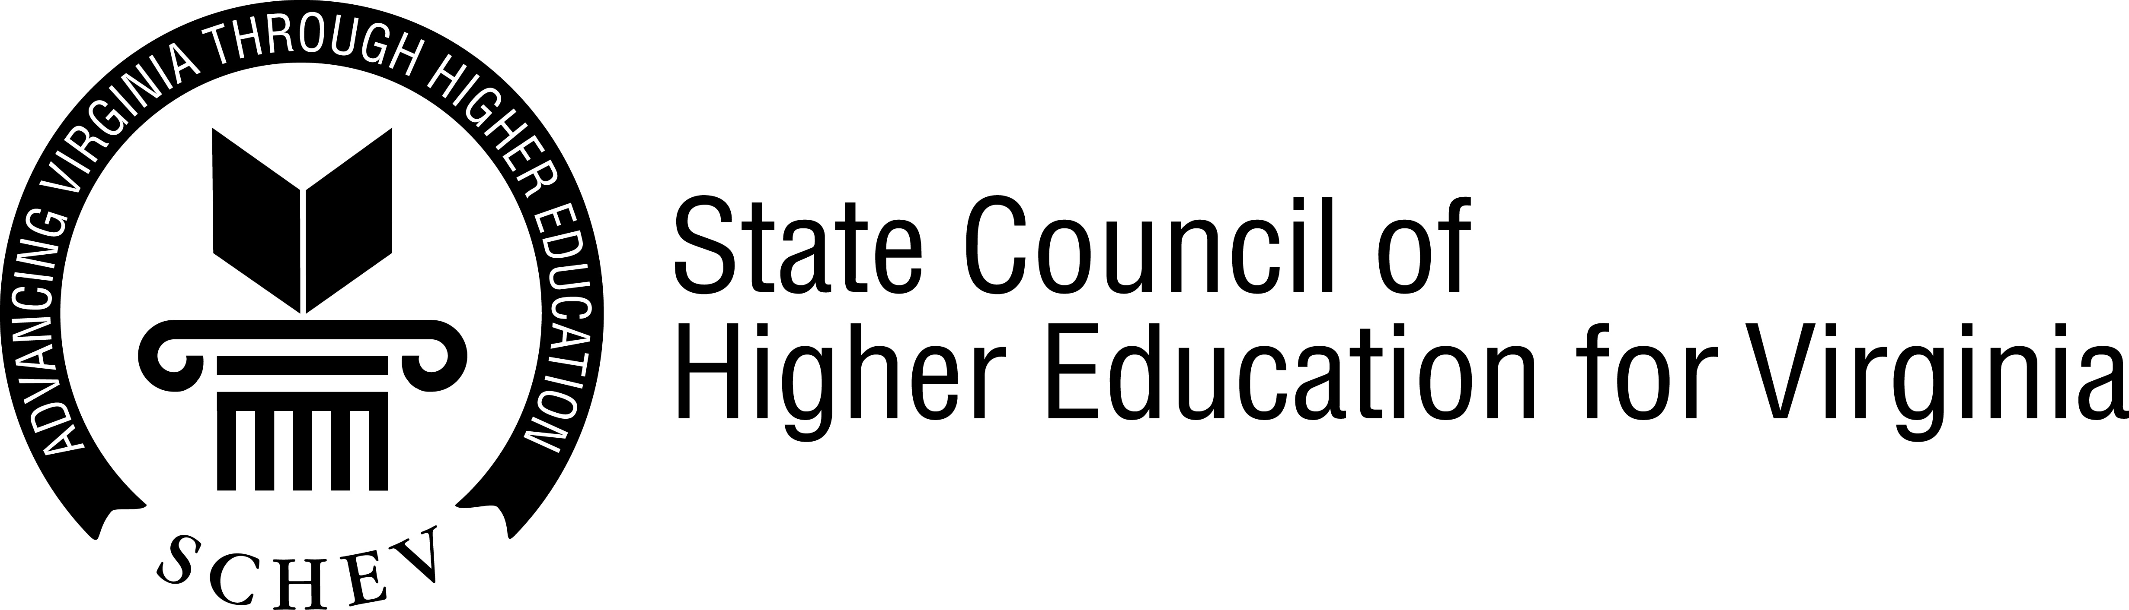
Certification
Cedar Stone School of Massage is certified to operate in the
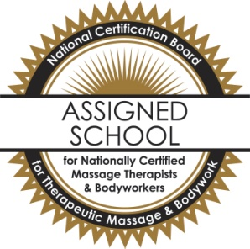
State of Virginia by the State Council of Higher Education
for Virginia.
Cedar Stone School of Massage is accepted as an assigned school for
National Certification in Therapeutic Massage and Bodywork.

General Description of Space, Equipment and Facilities

The school consists of 3000 square foot facility housing 2 classrooms, student clinic therapy areas, a small library, school lounge, and administrative offices. The classrooms are set up with massage tables, anatomical models and drawings, and video screens. The classrooms provide space for supervised practice and class instruction. The facility is situated in Harrisonburg City on 1.5 acres with room for student parking. All classes and supervised practice will be offered at Cedar Stone School of Massage, 1834 South Main Street, Harrisonburg, Va.

Massage Therapy Certification Program

Cedar Stone School of Massage offers a Massage Therapy Certification Program. The program prepares students for employment in the profession of massage therapy. The program integrates several approaches to massage and bodywork including Western, Native American and Asian techniques. Students study Swedish massage, deep tissue, mobilization, hot and cold stones and Shiatsu in addition to Anatomy, Physiology, and Pathology. Introductory classes are offered in various other modalities. The program may be undertaken on a full or part-time basis.

Educational Objectives
The Cedar Stone Massage Therapy Certification Program strives to prepare students to enter the field of massage therapy as a professional with massage and assessment skills, basic business knowledge, and a practical understanding of ethics and other professional skills as it relates to massage therapy. As such, the program seeks to assist students:

- Acquire the many skills necessary to perform therapeutic massage.
- Gain a thorough knowledge of anatomy and physiology as it applies to massage.
- Understand ethical issues relating to massage.
- Learn basic professional business practices.

The Massage Certification Program, includes:

Semester Classes
- Level I Massage
- Level II Massage
- Level III Massage
- Anatomy and Physiology
- Mobilization Techniques
- Muscle Actions
- Pathology
- Advanced Lab
- Track Class(es)
- Student Clinic

40 Hours of Electives
  - Aromatherapy
  - Intro to Trager
  - Intro to Cranial-Sacral
  - Introduction to Thai Massage
  - Self Care for the Practitioner
  - Marketing Your Practice
  - Other electives TBA

And Eight hours of CPR and First Aid

The Massage Certification Programs meet the national requirements for massage licensure and certification. Students complete 757 hours of instruction. Students may take coursework for to satisfy requirements for NCBTMB’s Board Certification or coursework to complete Virginia basic certification requirements and sit for the MBLEX national massage exam.

Upon completion of the program, students will be awarded a certificate and be eligible to sit for the National Certification Board for Massage Therapists and Bodyworkers’ exam or the Massage and Bodywork Licensing exam (MBLEX) and apply for Virginia state licensure as a certified massage therapist.

Class Schedule
CSSM offers a day or night time classes. Students may select the classes that best meet their scheduling needs. Generally, morning classes are offered from 9:00a.m.-12:30p.m. Evening classes are scheduled Monday-Thursday 5:30-9:00p.m.

Lab Schedule
Supervised lab is open Monday-Saturday. Students generally are required to complete 3-4 lab hours per week.

.
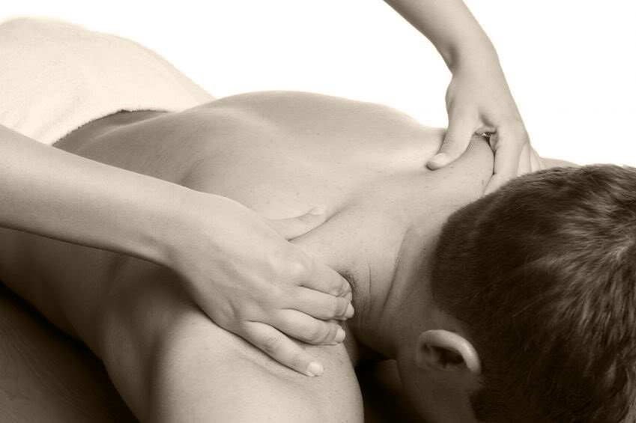
Massage for Friends and Family

Students who want to develop skills to use at home can enroll in the Level I Massage Therapy Class (see Course Description for details.) This class lays the foundation for practicing massage, providing an overview of the musculoskeletal system, Swedish massage techniques and introductory pathology. Students learn a full body relaxation massage, proper body mechanics, and contraindications for relaxation massage. The class is 90 hours, meeting for 15 weeks, 3 weekly hours of instruction and 45 hours of supervised practice.

Continuing Education

CSSM offers Continuing Education throughout the calendar year. The continuing education classes are provided to meet massage therapists’ re-certification requirements. Please visit our office or email us for the current schedule of workshops. Classes offered include Reflexology, Lymph Drainage, Rain Bath, Healing Hands and other Native American Treatments, Introduction to Thai Massage, Practitioner Self Care, Aromatherapy, Movement Studies, and others TBA.
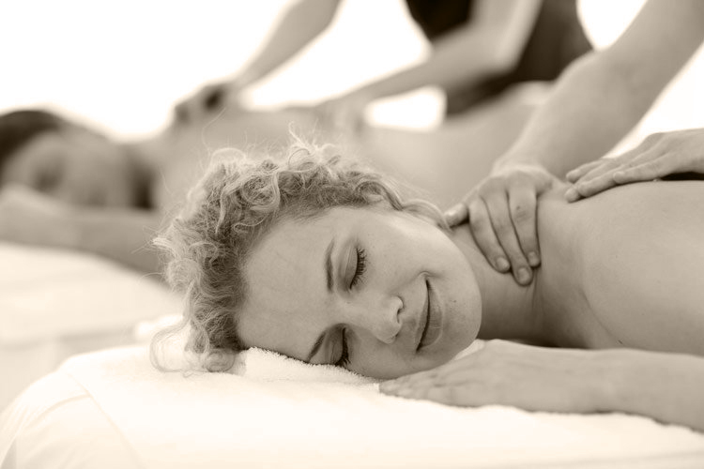
C ourse Descriptions

Level I Massage Therapy Class - 4 credit hours
Massage Therapy I provide students with the first level of massage education. Students learn a full-body relaxation massage in the Swedish tradition, seated massage, and introductory Stone techniques and theory. Learn basic anatomy and physiology focused on the musculoskeletal system and proper body mechanics. This class lays basic framework for the art of massage practice. It is appropriate for students pursuing a professional career in massage therapy as well as those who wish to share massage with family and friends. The class meets for 15 weeks, 3 weekly class hours or 45 clock hours.

Class hours include 23 hours in Massage Theory, 15 hours of Anatomy, 2 hours of ethics and 5 hours of Pathology. 45 supervised practice hours are required. Check the practice lab hours to schedule for practice times. Total hours: 90

Level II Massage Therapy Class - 5 credit hours
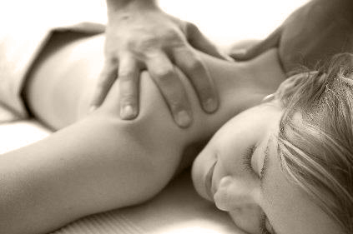
Students learn deep tissue massage theory and techniques. This class surveys muscle group anatomy, intermediate pathology, client interaction practices and assessment skills. Students will complete a lab project focused on treatment design, record keeping, and treatment delivery. Upon completing this course, students can perform an initial client intake and offer a full body therapeutic massage. Completion of Level I Massage is required to enroll.

This class meets for 15 weeks, 3.5 weekly class hours or 52.5 class hours. Class hours include 24 hours of Massage Theory, 22.5 hours of Anatomy, 1 hour of ethics and 5 hours of Pathology. 60 supervised practice hours are required. Check the practice lab hours to schedule practice times. Total hours: 112.5

Level III Massage Therapy Class - 5 credit hours
This class focuses on the design and integration of healing techniques through 5-Element Theory, Acupressure techniques and Shiatsu. Students learn acupressure, or Shiatsu and Hara diagnostics while exploring western and eastern massage philosophy and modalities. Students also begin an ethical exploration of the therapeutic relationship. Students practice the integration of massage techniques and energy-work in treatments tailored to meet the needs and pathology of individual clients. Completion of Level I Massage is required for enrollment.

This class meets for 15 weeks, 3.5 hours, or 52.5 class hours. Class hours include, 28.5 hours of related field theory, 14 hours of ethics, 5 hours of anatomy, and 5 hours of pathology. There are 50 supervised practice hours that can be done at one’s own pace. Check the practice lab hours to schedule practice times. Total hours are 102.5.

Anatomy and Physiology Class - 2 credit hours
An in-depth study of western anatomy and physiology, including understanding pathological processes as they relate to massage. Specifically, body systems such as nervous, digestive, circulatory, respiratory, endocrine, and immune systems are studied. Meets 15 weeks, 2.5 weekly class hours or 37.5 total hours. Class hours include 30 hours of anatomy and 7.5 hours of pathology.

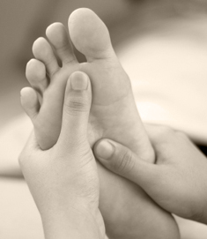
Pathology - 2 credit hours
An advanced study of pathology and the application of massage therapies and energy work. Students learn to design treatments based on the individual needs of the client. Completion of Level II Massage is required for enrollment in this class. Meets 15 weeks, 2.5 weekly class hours and includes 4 hours of massage theory, 29.5 hours of pathology, 1 hours of ethics and 3 hours of related field theory. Total hours: 37.5

Muscle Actions – 2 credit hours
Broaden your knowledge of specific muscle function. Students learn and practice the actions associated with each muscle through movement. Review of origin and insertions and general anatomy with a focus on assessing muscular function via movement patterns and range of motion. Meets 15 weeks, 2 weekly class hours and includes 30 of anatomy. Total hours: 30

Advanced Lab - 5 credit hours
Practice service delivery of massage in the student clinic. Participate in a group process to review client services, integration skills, treatment design, record keeping, pathology, and assessment. Study business practices and marketing. Meets 15 weeks, 2 weekly class hours and includes, 17.5 hours in business practices and ethics, 12.5 hours in theory application and 52.5 clinic hours. Completion of Level II Massage is required. Total hours 82.5.

Stretching and Joint Mobilization - 4 credit hours
Take a three-dimensional approach to delivering massage. Students learn to incorporate active and passive stretches for clients with common muscle and joint related complaints. Identify and examine the properties of muscular health in order to broaden massage practice to include stretching, breathing and mobilizing. The techniques for this work are derived from traditional Thai Bodywork, Yoga, Feldenkrais, Laban, and other modern movement theorists. Meets 15 weeks, 3 weekly class hours or 45 class hours and includes 25 lab practice hours. 17.5 hours of massage theory, 22.5 hours of anatomy and 5 hours of pathology. Total hours: 70

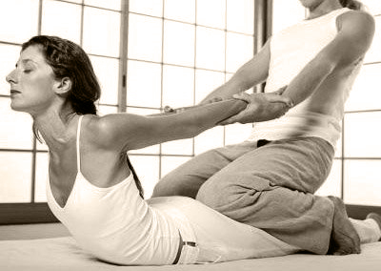
Track Class – 5 credit hours
Students may select one of the following track topics to specialize: Neuromuscular Massage, Sports/Movement Massage, Lymphatic Massage, or Cranial Sacral Massage. This class will focus on the treatment modality theory, associated pathologies and applications. Students will learn techniques and advanced treatment designs to specifically address client symptom presentations.

This class meets for 15 weeks, 3.5 weekly class hours or 52.5 class hours. Class hours include 32.5 hours of massage theory, 5 hours of anatomy, and 15 hours of pathology. There are 60 supervised practice hours that can be done at one’s own pace. The sixty hours are to be completed by the end of the 15 weeks. Check the practice lab hours to schedule practice times. Total hours are 112.5.

Student Clinic – 3 credit hours
Students will work in our clinic serving our local community. Students will provide full session massages in a clinic setting. This clinic class will prepare students to make the transition from student to professional massage therapist. Service delivery protocols including ethics, treatment design and record keeping are practiced. Total hours are 34, 2 hours of ethics and 32 hours of application.

Elective Training
During each semester, Cedar Stone offers a selection of elective trainings which introduce topics and bodywork modalities directly related to massage therapy and community outreach through chair massage events. Elective topics vary from semester to semester and include such classes as practitioner self-care, aromatherapy, Alexander technique, reflexology, successful business practices, and how to establish a massage practice. Other courses will be announced. Massage Therapy Certification students are to complete 40 hours of elective training (20 hours in community outreach events and 20 hours in course trainings) and an 8-hour CPR class to meet the requirements for graduation.

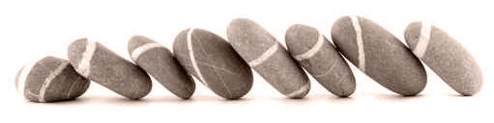

Academic Support Services

The school lab manager provides the following services to assist students in their academic and skill development, personal and professional growth and career advising.

Services:
- Academic Tutoring
- Skill Tutoring
- Student Advising

Students can meet with the lab manager to schedule tutoring/advising sessions. Class Instructors post semester office hours for student questions and course advising at the beginning of each semester. Please refer to your class syllabus or the school website for specific instructor availability.

The school also offers personal development programs to deepen one’s effectiveness as a healing arts practitioner and/or massage therapist. Please check with the school administrative office for a current listing of program availability.

Program Success

CSSM utilizes several tools to measure program effectiveness. Analyses of our graduate and certification rates are prepared annually. We survey our community employers to determine the school’s success rate in meeting their service needs with our graduates. We also collect evaluations from our student clinic clients to determine the effectiveness of our student massage. Additionally, our students complete exit interviews and program evaluations upon graduation. All of this information is used to evaluate the school’s success and determine program strengths and weaknesses.

General Procedures/Policies

Cedar Stone School of Massage is committed to providing excellence in our educational programs and student preparation for entrance into the healing arts profession. The following procedures, policies and guidelines form a structure to ensure our delivery of excellence to our students, our profession and our community-at-large.

Admission Procedure

Applicants must be at least 18 years of age and have a high school diploma or equivalent. Students must be physically capable of performing massage techniques taught in the class. Outlined below are the admission requirements/procedures.

Enrollment in the Massage Therapy Certification Program

Prospective students should complete a Massage Therapy Certification Program application form, provide a completed personal, non-relative, reference form, and submit an application fee of $50. Applicants must, provide a copy of their high school/GED diploma or transcript and complete an interview with a member of our staff. The interview provides an opportunity for students to explain their personal and professional goals, to ask questions, and provides our staff with information to best meet the individual student’s needs. Applicants will be notified by mail or email of their acceptance into the program.

Enrollment in Level I Massage Therapy Class

Prospective students should complete a Level I application form, submit an application fee of $50 and complete an interview with a member of our staff. The interview provides an opportunity for students to explain their personal and professional goals, to ask questions, and provides our staff with information to best meet the individual student’s needs. Applicants will be notified by mail or email of their acceptance into the class.

Enrollment in the Continuing Education Series

Prospective students should complete the registration form for the class selected and submit the deposit fees as directed on the registration form. The instructor of each class will confirm a student’s registration.

Enrollment Dates

A student may enroll at any time prior to the start of a new class. The school has rolling admissions. A new massage professional program starts every September, January and May. Based on student demand, there may be mid-semester start dates of March, July and October. Registration dates for continuing education classes vary for each class. Please check with the school office, website, and flyers or email this office for registration information.

Credit for Previous Training

Applicants with previous massage therapy education and experience may be awarded credit for their previous training. Please provide transcripts from institutions previously attended with a Cedar Stone application form. Our staff, after review of prior training and an interview with the applicant, will determine appropriate credit and placement in this program. An applicant may be asked to take a practical and/or written exam for this credit.

Credit Transfers

Credit for classes earned at CSSM may or may not be transferred to other institutions. It is the sole discretion of the receiving school as to what coursework and/or credits will be transferable.

Standards of Progress
Student’s progress in all courses in the Massage Therapy Certification Program will be assessed by classroom observations, written exams, and a practical manipulative skills exam. Students are allowed to retake a failed written or practical exam one time. The grading scale is outlined below:

A 90-100 Superior 4 points
B 80-89 Above Average 3 points
C 70-79 Average 2 points
F Below 70 Failure 0 points
I Incomplete 0 points
W Withdrawn 0 points

Students must successfully complete each massage course before progressing to the next course. In order to graduate from the Massage Therapy Certification Program or to receive a certificate from the Level I class, a student must receive a passing grade (70 or better) in all classes attempted. A student’s grade-point average is computed by the following: total points/total units of credit attempted = grade point average. A student must maintain a cumulative 2.0 GPA to complete the program. Our staff will gladly assist students for successful completion of each class.

Students receive semester grades via email at the end of each semester. The student’s program GPA is included in these progress reports.

Practical Examinations

A practical exam is given in each of the Massage Program classes. The exam requires the integration of practical skills and academic knowledge. It is an opportunity for the student to demonstrate a synthesis of their knowledge, skill and art of massage therapy. The practical exam will be 40% of the class final grade.

Graduation Requirements –

Massage Therapy Certification Program

- 70% passing grade in each of the seven courses and a 2.0 or better GPA
- Satisfactory completion of lab hours in each course
- Completion of 40 hours electives
- Completion of CPR & First Aid training
- All fees paid in full

A certificate is given upon completion of these requirements.

Student Records

All student evaluations and grades are maintained by the school for a period of five years. Student transcripts are kept on file permanently and are protected from fire, theft and other perils. All student files are kept confidential and secured, only authorized school personnel have access to student records. Students may request in writing a copy of their academic transcripts. Students must give the school written permission via email, fax or letter for any other person or organization to receive student transcripts.

Student Right-To-Know and Campus Security Act

An annual school progress report is issued at the beginning of Fall Semester. The report includes graduation and certification rates and all other information pertinent to our school as it relates to the Student Right-To-Know and Campus Security Act.

Career Placement

Cedar Stone School of Massage provides an information board of local job availability. Although the school cannot guarantee employment upon graduation, every reasonable effort will be made to help students apply their newly acquired skills to the job market. The school provides transcripts and letters of completion for graduates upon request. Massage therapists frequently are self-employed. With this in mind, the school educates students about successful business ethics and practices.

Attendance Policy

We encourage students to attend all classes, or maintain 100% attendance. If a student cannot attend class, please contact the school prior to class. Our staff will assist the student to make-up missed class work. The fee for the first make-up class is $0. Additional make-up classes are $50 per class. If a student misses 7 consecutive unexcused instructional days, the student will be administratively withdrawn from the program..

If a student has chronic absenteeism, (attendance is 85% or less), the student shall meet with the student advisor to determine a plan to correct the absenteeism. If the plan is not met, then the student shall be placed on conduct probation. The student shall meet with the school director to determine a plan for removal from probation. If this probation plan is not met, the student shall be suspended for the remainder of the semester. The student may return the following semester under the original plan of their conduct probation. If the student is unable to meet the terms of the probation plan then the student will be dismissed from the program

Tardiness Policy

Students are encouraged to arrive on time for class and stay the entire class. Students will be considered tardy if they arrive 15 minutes late. Three semester tardies will constitute one absence. Instructors use their discretion in extending credit for attendance or initiating student discipline.

Leave of Absence

Students may request a leave of absence at any point during the program/class. The student must submit a written notice to the school explaining the reason they are requesting the leave. The student can meet with the school director to determine a plan for his/her return to school.

Academic Probation

A student will be placed on academic probation if the student is unable to maintain a 2.0 cumulative GPA or drops below 70 in any class will be placed on academic probation for the following semester. The student will be given extra assistance, and a plan developed by the student advisor to enable the student to reach the expected level of performance. Once a 70 and/or a 2.0 cumulative GPA is reached, the student will be removed from academic probation.

Academic Suspension or Termination

At the end of academic probation, if the student has not brought his/her grade to meet 70 and/or a 2.0 cumulative GPA then the student’s progress shall be reviewed by the academic review committee. The committee will then recommend a new probation plan, suspension or termination. The student has a right to appeal the decision to the school’s director. The appeal should be submitted in writing within 10 days of the committee’s decision.

Student Conduct and Conditions for Dismissal

Students are to conduct themselves in an orderly and professional manner, which includes honoring the NCBTMB Code of Conduct and Ethics. Any student not honoring the NCBTMB code of conduct, using drugs and alcohol during school hours, being dishonest, disrupting classes, violating safety rules, insubordination, or not abiding by the class rules set by the instructor will lead to either conduct probation or dismissal from the program/classes.

If the student is placed on conduct probation, the student shall meet with the school’s director to determine a plan including a date for removal from conduct probation. If the terms of the probation plan are not met, the student will be dismissed from the program/class. The student may appeal the dismissal decision using the grievance procedure listed below.
Re-entrance

Any student, who has dropped out of the program, may be readmitted within one year by completing a personal interview with the school’s director or student advisor, completing a re-entry application, and paying all fees due at the time of readmission. Program requirements at the time of re-admittance shall be applicable.
Any student, who was academically terminated, may be readmitted after one year by completing a personal interview with the school’s director or student advisor, completing a re-entry application, and paying all fees due at the time of readmission. The student shall be on academic probation for his/her first semester.

Any student who was dismissed from the program for conduct may not be readmitted.

Student Grievance Procedure

Cedar Stone School of Massage sets the following grievance procedure to ensure fair student grievance process and resolution. Any student who has a grievance with an instructor should first discuss the problem with the instructor. If a resolution is not reached, the student may submit a written complaint to the school director. The school director can meet with the student to reach a resolution. If no resolution is reached, the director can refer the grievance to the grievance committee. After the grievance committee meets with the student, the committee will submit written findings to the school director and student. If there is still no resolution obtained, the student may contact:

State Council of Higher Education for Virginia (SCHEV)
James Monroe Building, 9th Floor
101 North 14th Street
Richmond, VA 23219
804-225-2600
804-225-2604 (Fax)

Students will not be subject to unfair actions as a result of initiating a complaint.

Statement of Students’ Rights, Privileges and Responsibilities

The students of Cedar Stone School of Massage have the right to the education they have paid for and the right to file a grievance under the procedures listed above if any problem ensues. Students have the right to have access to their student files. All student records are confidential. Students have the responsibility to adhere to the school conduct policy and to complete all academic, attendance and financial responsibilities.

Specifically, students will:

- Be responsible.
- Be respectful.
- Cooperatively work with faculty and administration staff in the program to ensure success.
- Acquire learning skills.

  - Become more self-aware, self-managed, and self-directed.
  - Offer and seek peer support when needed.
  - Seek support from school staff when needed.
  - Develop constructive relationships.

- Track their graduation requirements, using a credit checklist.
- Be an active player in their career planning, including developing a personalized career plan
- Participate in program evaluation.

Fees and Expenses

The fees for the Level I Class and the Massage Therapy Certification Program are outlined below. Students who start in Level I and then enroll in the Massage Therapy Certification program will be credited toward the total program tuition. Students may pay school fees in total, by semesters or in monthly installments. Tuition due dates are as follows: Semester tuition payments are due the first class of each semester. Monthly tuition payments are due the first of each month.

Level I Massage Class (15 weeks) - $1200
Application Fee: $50
The remaining tuition of $1150 can be paid in full by the first class or 4 monthly payments of $287.50.

Massage Therapy Certification Program
The Massage Therapy Certification Program is 37 credit hours. Each credit hour is $295. Total program cost is $10,915.

Students are billed at the beginning of each semester based on the program payment plan they have registered. Students may pay the total semester amount on the first day of class or make monthly payments throughout the program.

Program Discount
Students who pay in full will receive a 10% discount.

Textbooks
Textbook fees will vary by class. Please see the class instructor or visit our website to see the required textbooks for each class.

Other Expenses
Students are asked to provide linens and oils/creams for class and practice hours. Massage tables will be provided at the school. Students will need to purchase a table for home or business use. Massage stones are provided for class. Students will need to purchase stones for home or business use. Our staff will guide students with the purchase of these items during the program.

Students are also required to pay for their CPR certification. CSSM offers CPR classes on campus.

Scholarships

There are currently no scholarships available.

Financial Aid

Currently there are several payment plans available. Please check with the CSSM staff for detailed information.

Cancellation/Refund Policy
7-Day Cancellation: A full refund can be made if the student decides to withdraw within 7 days of enrollment. The student must provide written notice of cancellation within 7 business days (excluding holidays and weekends) of executing the enrollment agreement. A student who withdraws or cancels after 7 days and prior to the first class will be refunded all tuition paid excluding the application fee of $50.

Withdrawal Procedure:

- A student who withdraws after the first class will submit a written notice to the school director. The notice should include the expected last date of attendance and be signed and dated by the student.

- If special circumstances arise, a student may request, in writing, a leave of absence, which should include the date the student anticipates the leave beginning and ending. The withdrawal date will be the date the student is scheduled to return from the leave of absence but fails to do so.

- A student will be determined to be withdrawn from the institution if the student misses 7 consecutive instructional days and all the days are unexcused.

Refunds: If a student enrolls and withdraws or is discontinued after submission of the first completed lesson assignment, but prior to the completion of the program. Minimum refunds are calculated as follows:

- A student who starts the program but withdraws up to and including completion of the first quartile (25%) of the program is entitled to receive as a refund a minimum of 75% of the stated cost of the course or program for the period.

- A student who starts the program but withdraws after completing up to the second quartile (more than 25%, but less than 50%) of the program is entitled to receive as a refund a minimum of 50% of the stated cost of the course or program for the period.

- A student who starts the program but withdraw after completing up to the third quartile (more than 50%, but less than 75%) of the program is entitled to receive as a refund a minimum of 25% of the stated cost of the course or program for the period.
- A student who withdraws after completing the third quartile (75%) or more of the program is not entitled to a refund.

Refunds will be paid within 30 business days after the effective date of the termination.

Cedar Stone School of Massage Officers

Cedar Stone School of Massage is owned by Cedar Stone Healing Arts, LLC.

Sandra Hoak, M.A., Ed.S. President

List of Faculty and Administrators

Administrators and Faculty
School Director Sandra Hoak, M.A., Ed.S.
Instructor Alan Arnett, LMT
Instructor Leah Kilcup, LMT
Instructor Brandy Caplinger, LMT
Instructor Kathy Volrath, LMT
Instructor Dawn Burtner, LMT
Instructor Mariza Dovis, LMT
Operations Manager/Instructor Christine LaFrance, B.S., EMT, LMT

Academic Review Committee

Sandra Hoak, M.A., Ed.S.
Brandy Caplinger, LMT
Christine LaFrance, B.S.

Academic Excellence Committee
Sandra Hoak, M.A., Ed.S.
Christine LaFrance, B.S.
Leah Kilcup, LMT
Brandy Caplinger, LMT

Grievance Committee
Colleen Gorman, B.A.
Mariza Dovis, LMT
Victoria Ansell, LMT

